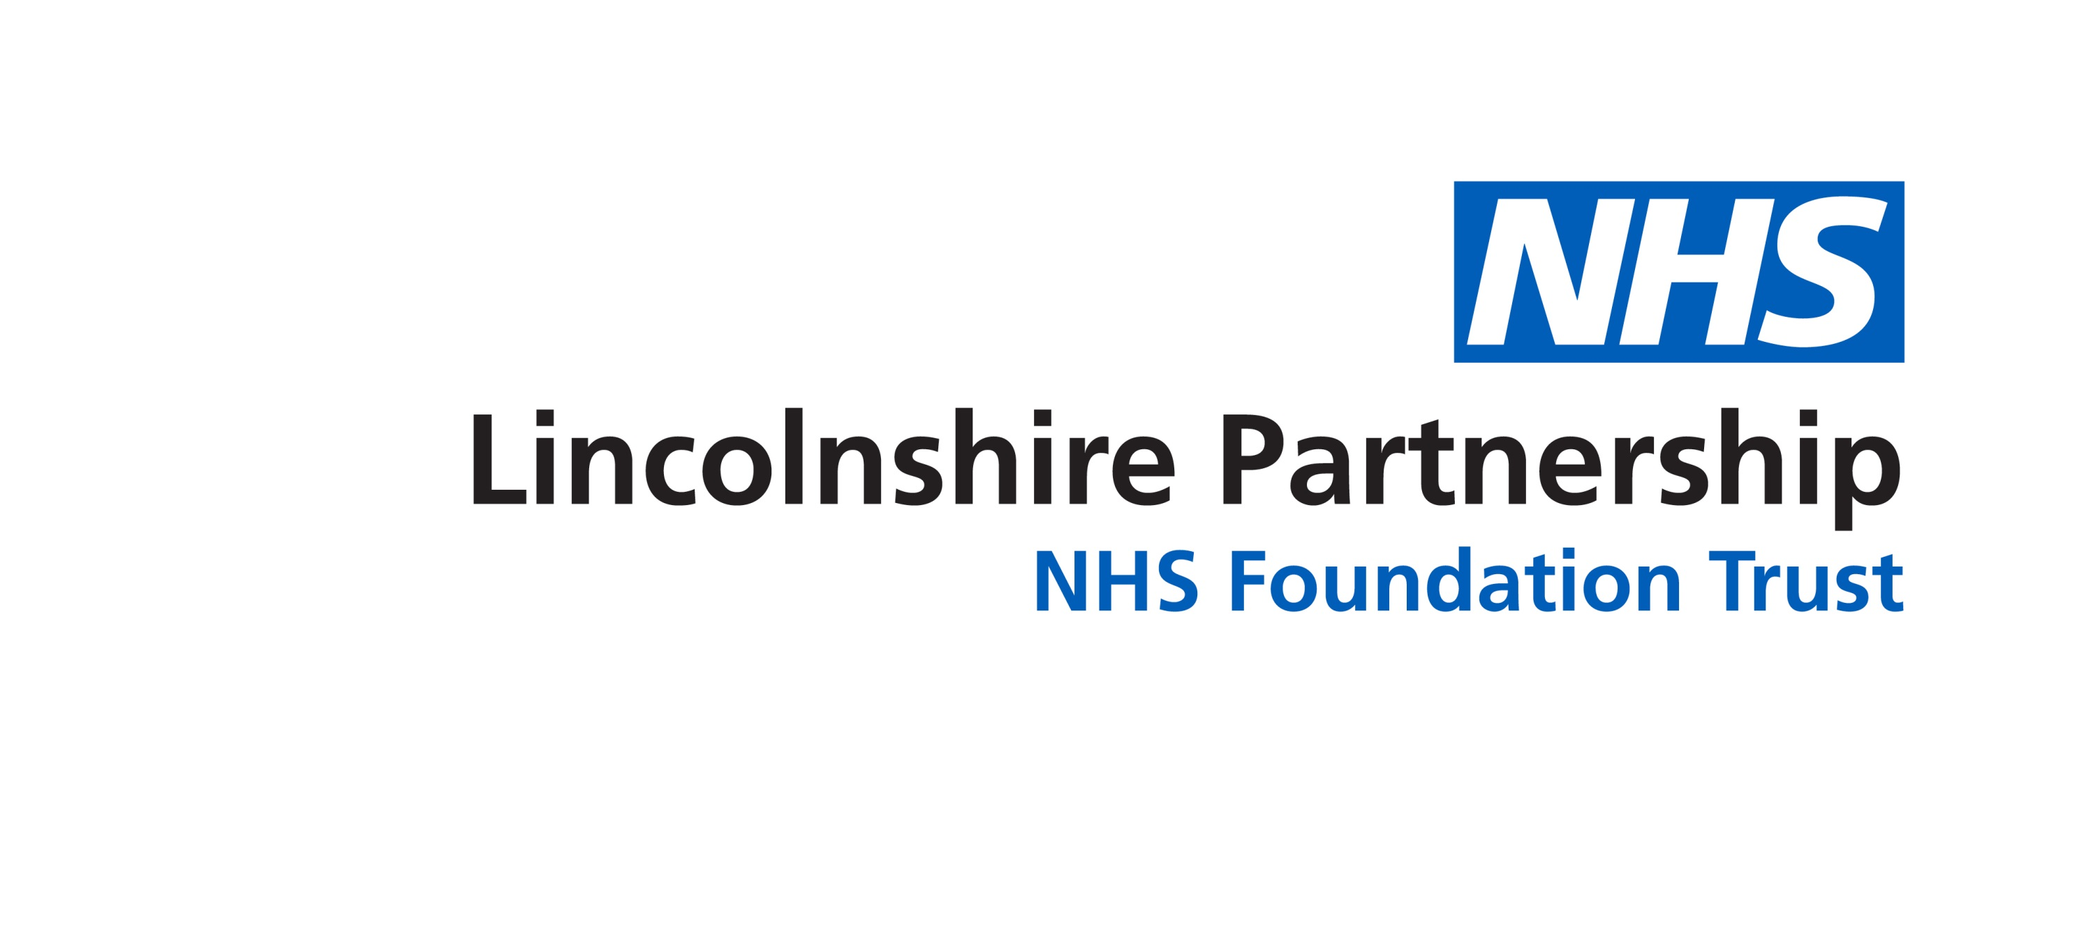

**My Circle of Wellbeing**

**4**

**3**

**2**

**1**

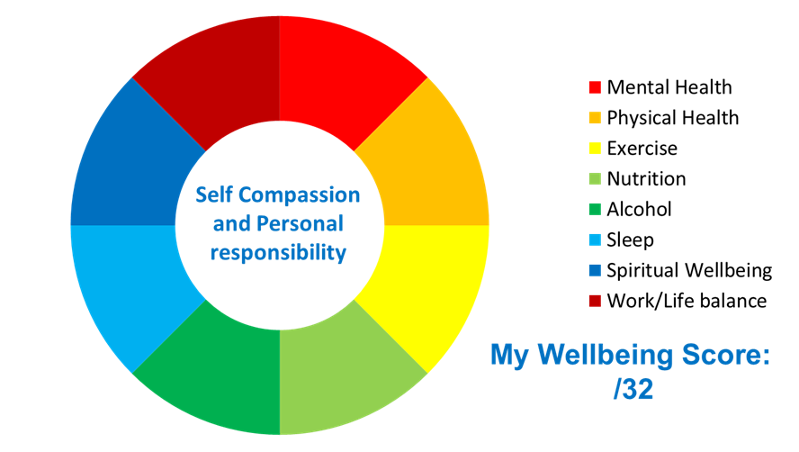

**Rating my wellbeing in each area (higher score= higher levels of wellbeing):**

**4- Strongly Supports 3- Supports 2- Interferes 1- Strongly Interferes**

**4**

**3**

**2**

**1**

**4**

**3**

**2**

**1**

**4**

**3**

**2**

**1**

**1**

**2**

**3**

**4**

**1**

**2**

**3**

**4**

**1**

**2**

**3**

**4**

**1**

**2**

**3**

**4**

**My Circle of Wellbeing**



* **Physical Health-** am I forever ‘picking things up’, do I regularly feel I need ‘a duvet day’, do I have a known health condition, do I smoke, am I/ could I be menopausal?
* **Nutrition-** do I eat 5 a day, drink 6-8 glasses water, am I a healthy weight, do I pee and poo regularly, feel energised by what I eat?
* **Sleep-** do I wake up feeling refreshed or regularly turn in for work feeling exhausted?
* **Work/Life Balance-** do I take work home with me, can I ‘switch off’, do I have ‘time for me’
* to do things I ‘get lost in’?
* **Mental Health-** do I feel stressed, anxious or fearful? Do I avoid things I would normally enjoy, am I more snappy, irritable?
* **Exercise-** do I do something active (makes me breathless) for at least 150 mins/week, do I sit less and move more, take the stairs, walk, skip, jump, dance whenever I can?
* **Alcohol-** do I drink 14 units/week or less with some alcohol free days?
* **Spiritual Wellbeing-** do I have something meaningful in my life I value which makes me ‘me’?



**My Circle of Wellbeing-**

**Resources available to me…**

|  |  |
| --- | --- |
| * **Mental Health** * SWS Individual therapy- counselling, CBT, Psychology, Occupational Therapy, * SWS Group based therapy- Up group (CBT based), Sleep group, Small Steps Big Changes (Selfcare based) * [NHS Moodzone](https://www.nhs.uk/conditions/stress-anxiety-depression/connect-for-mental-wellbeing/) * [Headspace](https://www.headspace.com/register?utm_source=google&utm_medium=cpc&utm_campaign=917256451&utm_content=51529951612&utm_term=227077126550&headspace&gclid=EAIaIQobChMImf-t7dGr3gIVS-h3Ch38aw56EAAYASAAEgKZjPD_BwE) | * **Physical Health** * SWS Occupational Therapy to manage long term conditions * SWS Physiotherapy for Musculoskeletal problems * SWS Pain management * SWS Fatigue management * [NHS Health Body](https://www.nhs.uk/live-well/healthy-body/) * [NHS Quit Smoking](https://www.nhs.uk/live-well/quit-smoking/) * [NHS Sexual health](https://www.nhs.uk/live-well/sexual-health/) |
| * **Exercise** * SWS supported Yoga, Zumba, Boxercise, Karate * SWS supported Global Challenge, Step into Spring challenge * SWS supported Cycle to work scheme, Gym discount * SWS Small group/ Individual sessions to support you to develop Wellbeing Circle action plan * [change4life](https://www.nhs.uk/change4life/) * [NHS Exercise](https://www.nhs.uk/live-well/exercise/) | * **Nutrition** * SWS Small group/ Individual sessions to support you to develop Wellbeing Circle action plan * [change4life](https://www.nhs.uk/change4life/) * [NHS Eat Well](https://www.nhs.uk/live-well/eat-well/) * [NHS Healthy weight](https://www.nhs.uk/live-well/healthy-weight/) |
| * **Alcohol** * SWS Small group/ Individual sessions to support you to develop Wellbeing Circle action plan * [NHS Alcohol Support](https://www.nhs.uk/live-well/alcohol-support/) * [Addaction](https://www.addaction.org.uk/help-and-support) | * **Sleep** * SWS Sleep course (4 half day sessions over 4 weeks) * [NHS Sleep and Tiredness](https://www.nhs.uk/live-well/sleep-and-tiredness/) * [National Sleep Foundation](https://www.sleep.org/) |
| * **Spiritual Wellbeing** * SWS Occupational Therapy * LPFT Chaplaincy service | * **Work/Life Balance** * SWS Occupational Therapy |

**My Circle of Wellbeing Action Plan**



|  |  |
| --- | --- |
| * **Mental Health** | * **Physical Health** |
| * **Exercise** | * **Nutrition** |
| * **Alcohol** | * **Sleep** |
| * **Spiritual Wellbeing** | * **Work/Life Balance** |